Press Release 4TH DEC 2025
FOR IMMEDIATE RELEASE
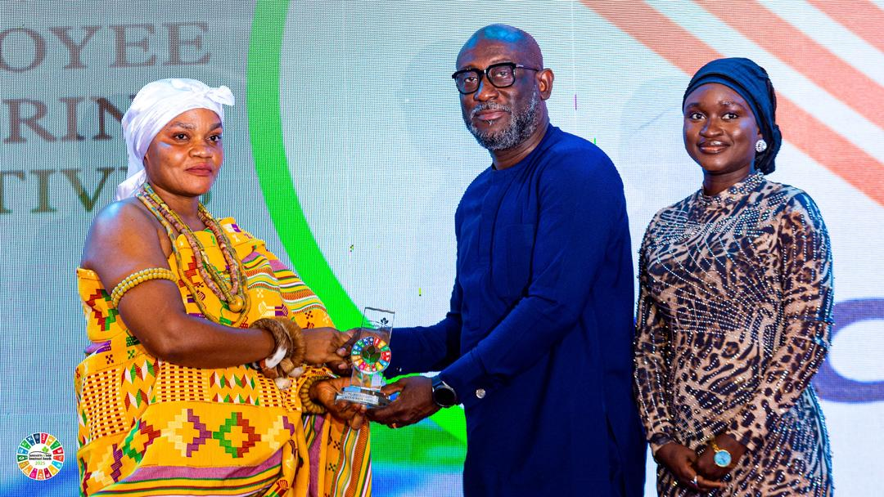
Head of Corporate Communications & Brand Management at Access Bank, Edward Nelson-Addy (M) receiving the award on behalf of the bank.
Access Bank Ghana wins two major honours at the 2025 Sustainability & Social Investment Awards
Access Bank (Ghana) PLC has reaffirmed its leadership in sustainable banking by winning two prestigious awards at the 2025 Sustainability & Social Investment (SSI) Awards held on Friday at the Movenpick Ambassador Hotel in Accra. The Bank was named Best Company in Employee Volunteering Initiatives and Best Company in Sustainable Financing & Investment, solidifying its reputation as a purpose-driven institution committed to empowering communities and driving positive environmental and economic change.
The recognition reflects Access Bank’s long-standing investment in people-centered initiatives, community development, and transformative partnerships that support national growth. Commenting on the awards, the Managing Director of Access Bank Ghana, Pearl Nkrumah, noted that the honour underscores the Bank's commitment to building a more sustainable future.
“Sustainability is not an event for us, it is a continuous journey that guides how we serve our customers, support our communities, and create impact. These awards reinforce the work we are doing through our employees and our strategic partners,” she said.
Under its Sustainable Finance mandate, Access Bank has rolled out a number of initiatives aimed at strengthening responsible lending practices, expanding support for Small and Medium Enterprises (SMEs), and driving innovation across Africa’s financial landscape. These include its partnership with Birmingham City University, which promotes green financing and capacity-building for SMEs, and its collaboration with the International Finance Corporation (IFC) to broaden access to finance for small businesses in Ghana, with a dedicated focus on women entrepreneurs. The Bank has also partnered with Mastercard to introduce a unified cross-border payment solution across key African markets, enabling individuals and businesses to send and receive international payments to and from more than 150 countries.
Further strengthening its impact on the SME ecosystem, Access Bank recently entered a strategic partnership with DHL Express Ghana to equip local businesses with the tools and support needed to expand into global markets. This collaboration aligns with the government’s agenda to accelerate SME growth as a catalyst for national development and taps into opportunities created by the African Continental Free Trade Area (AfCFTA).
In addition to its financial interventions, the Bank’s vibrant employee volunteering culture continues to make a meaningful difference across communities in Ghana. Staff of the Bank actively participate in numerous social initiatives each year, supporting programmes in education, healthcare, environmental conservation, and youth empowerment. This commitment played a key role in earning the Bank the award for Employee Volunteering Initiatives.
Access Bank Ghana remains dedicated to advancing sustainability, promoting financial inclusion, and providing innovative banking solutions that enhance the livelihoods of individuals, businesses, and communities.
-ENDS-
For further information, contact:
Edward Nelson-Addy
Head, Corporate Communications & Brand Management
E: Edward.Nelson-Addy@accessbankplc.com
Interact with Access Bank on LinkedIn: https://shorturl.at/8Sm6X

