Press Release 20TH NOVEMBER 2025
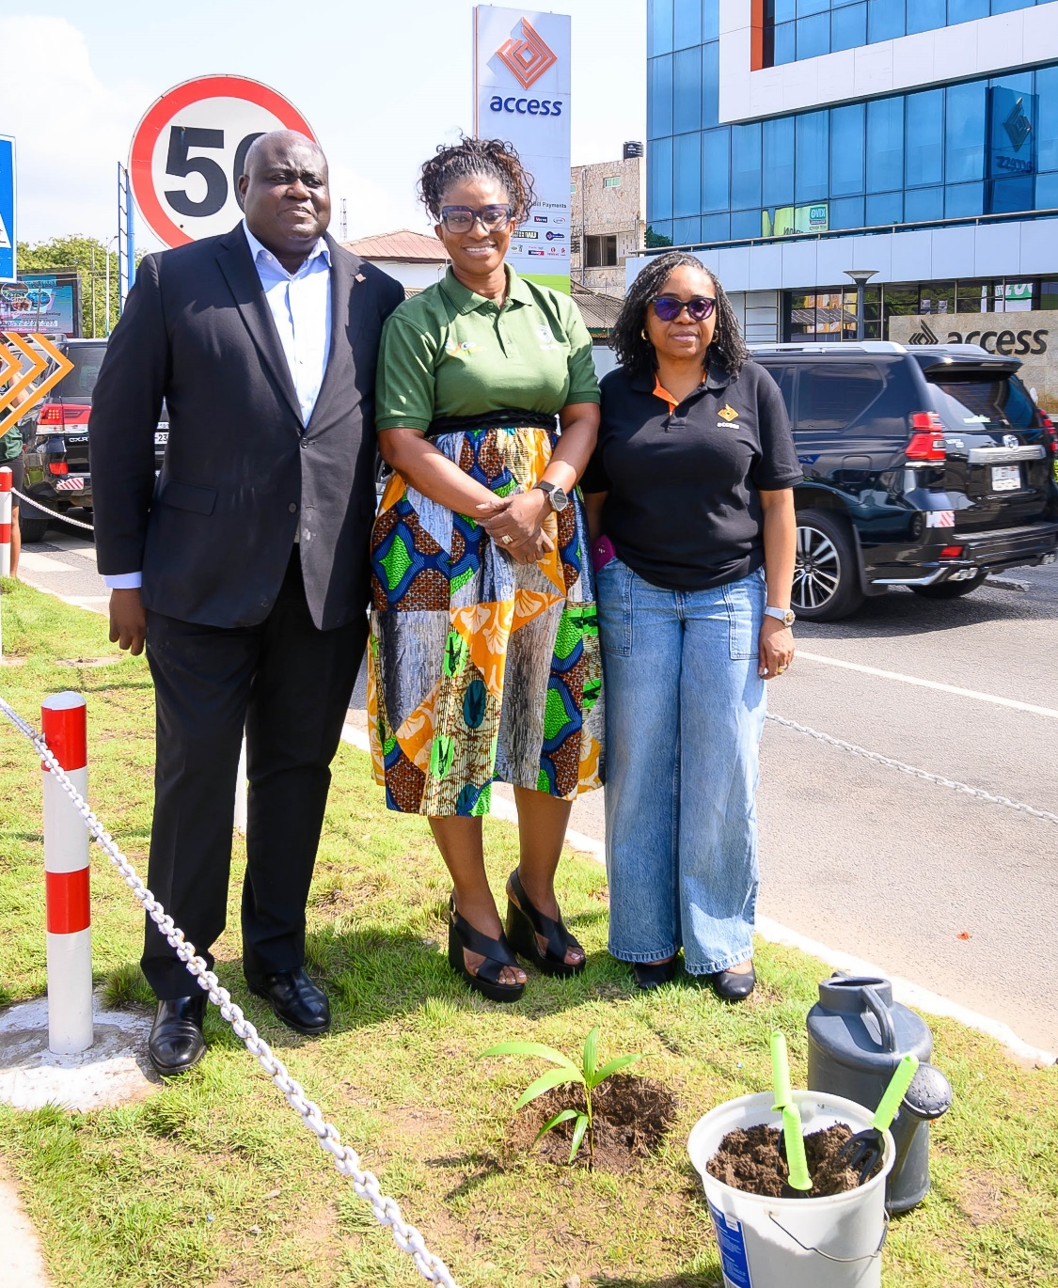
Managing Director of Access Bank Ghana, Pearl Nkrumah flanked by ED, Wholesale Banking, James Bruce (L) and COO, Ugochi Okoro (R)
ACCESS BANK SUPPORTS CEDI @ 60 WITH NATIONWIDE TREE PLANTING EXERCISE
Access Bank (Ghana) PLC has joined the national call to preserve the environment by taking part in a nationwide tree planting exercise to commemorate the Cedi @ 60 celebration led by the Bank of Ghana.
The activity, held on Thursday, November 20, 2025, saw staff across all Access Bank branches plant trees in the communities they serve. The initiative was undertaken in honour of Ghana’s currency, the Cedi.
Key members of Management of Access Bank, led by the Managing Director, Pearl Nkrumah; Executive Director for Wholesale Banking, James Bruce; Chief Operating Officer, Ugochi Okoro; Head of Corporate Communications, Edward Nelson-Addy, and the bank’s Sustainability Champions planted commemorative ornamental trees at the Bank’s Head Office in Osu and across its communities of operation.
The exercise reaffirmed the Bank’s commitment to sustainability and environmental stewardship as a core part of its business strategy.
Speaking on the nation-wide tree planting exercise, Managing Director, Pearl Nkrumah said, “we are delighted to support the Bank of Ghana as the nation celebrates 60 years of the Ghanaian Cedi. At Access Bank, our purpose goes far beyond banking. It extends to nurturing the wellbeing of our communities and safeguarding the environment we all share. The future of our people and the resilience of our climate are shaped by the commitments we make today. Through our collective action, we are helping to grow a greener, stronger, and more sustainable Ghana for generations to come”.
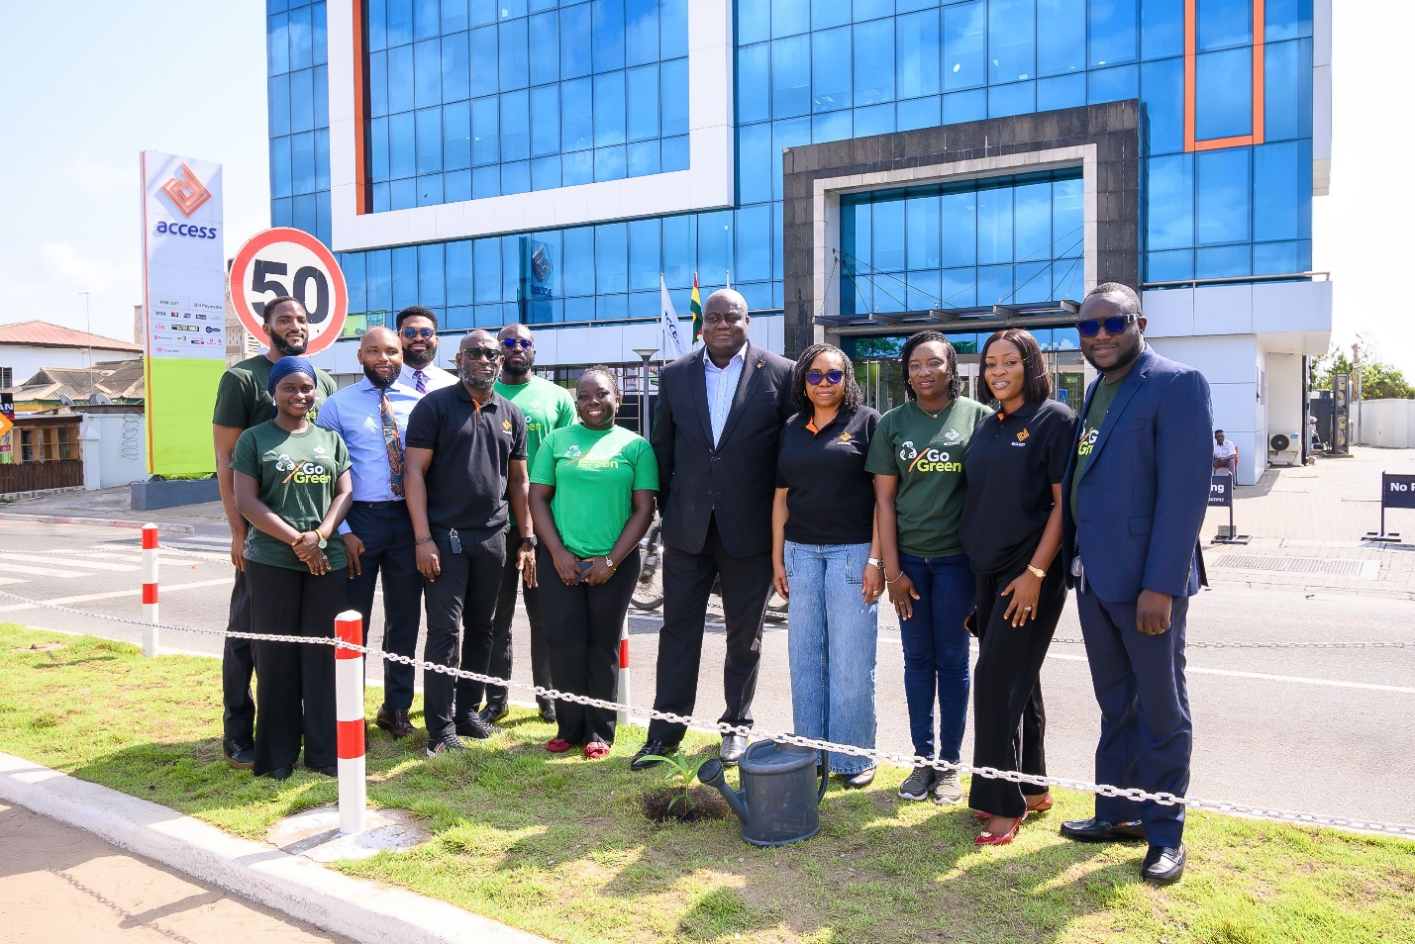
Ahead of the national tree planting day, Access Bank also participated in a week-long Cedi @ 60 celebration, which highlighted the evolution and significance of the currency in Ghana’s development journey.
Access Bank Ghana is a subsidiary of Access Bank Plc, one of Africa's leading financial institutions. Operating from 56 business locations across Ghana with presence in 23 countries in Africa and the rest of the world including the UAE, UK, Hong Kong and France along with three representative offices in China, India, and Lebanon, the Bank actively invests in initiatives that promote environmental conservation, community development, and social well-being in areas of environment, health, education and enterprise impacting lives now and in the future.
Access Bank Ghana has been recognized for its outstanding sustainability practices through various prestigious awards, including the Ghana’s Best Bank in Environmental, Social, and Governance (ESG) at the 2024 Euromoney Banking Awards for Excellence, Project of the Year, Environment from Sustainability & Social Investment (SSI) awards in 2023 and the Most Innovative Bank for Community Engagement from International Finance awards in 2024. The Bank has over the years developed a deep understanding of its customers, delivering excellent services and empowering them to achieve more through financial education and inclusion.
-ENDS-
For further information, contact:
Edward Nelson-Addy
Head, Corporate Communications & Brand Management
E: Edward.Nelson-Addy@accessbankplc.com
Interact with Access Bank on LinkedIn: https://shorturl.at/8Sm6X

