Press Release 25TH NOVEMBER 2025
FOR IMMEDIATE RELEASE
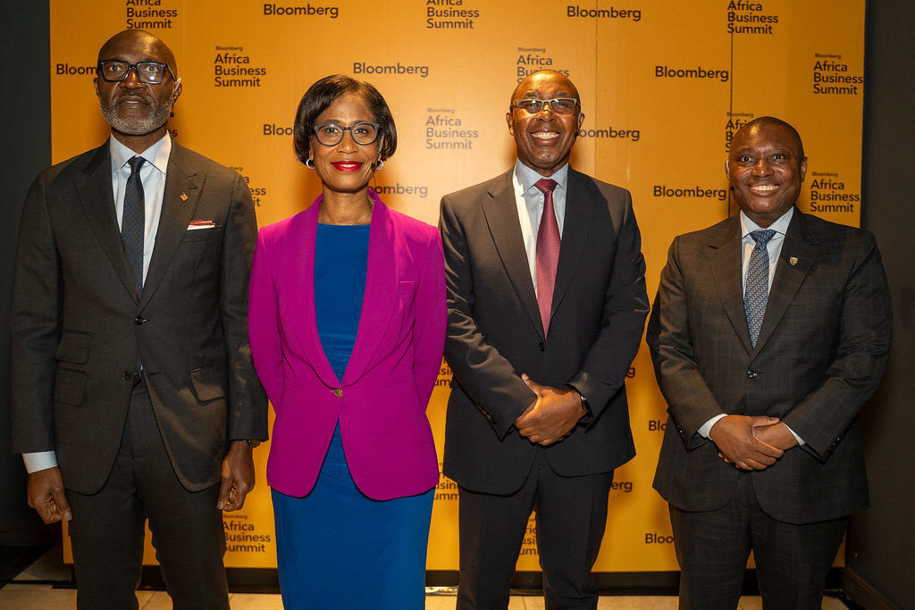
Roosevelt Ogbonna, Managing Director/CEO of Access Bank (far left) in a photo with CEO of Standard Bank Group & Group CEO of Absa
Roosevelt Ogbonna Outlines Vision for Future of Banking in Global Africa at Bloomberg Africa Business Summit
At the recent Bloomberg Africa Business Summit, some of the continent’s most influential banking leaders convened to address a defining question for Africa’s economic trajectory: How can the continent sustainably fund its own growth in an increasingly interconnected world?
Roosevelt Ogbonna, Managing Director/CEO of Access Bank, delivered a compelling perspective on this theme, offering a forward-looking view of what banking in a “Global Africa” must become, at the Bloomberg Africa Business Summit which held in Johannesburg recently.
Speaking to an audience of global investors, policymakers, and private-sector executives, Ogbonna began by highlighting the underlying resilience of African markets despite prevailing geopolitical uncertainties. Citing Nigeria’s most recent Eurobond issuance, which was oversubscribed multiple times, he noted that investor appetite continues to respond positively to reform-driven environments.
“Markets are more intelligent than the narratives that often surround Africa,” Ogbonna stated. He emphasized that transparency, disciplined governance, and sustained policy reforms are sending clear signals that resonate with global capital pools. These conditions, he added, are laying a stronger foundation for financing Africa’s next phase of growth.
Looking ahead, Ogbonna, who spoke alongside Sim Tshabalala, CEO of Standard Bank Group and Kenny Fihla, Group CEO of Absa Group, articulated a bold vision of Africa not merely as a consumer market, but as a global hub for trade, innovation, and production. With abundant talent, natural resources, and emerging technological infrastructure, the continent is ideally positioned to move up the value chain, from exporting raw materials to manufacturing and delivering value-added products domestically.
For Access Bank, he explained, this translates into a commitment to full-spectrum banking that supports every layer of economic activity: retail, SMEs, corporate entities, and investment-driven sectors such as renewable energy, digital infrastructure, and industrial processing.
Ogbonna further underscored the strategic advantage for African banks as many Western institutions reduce their footprint across the continent. Access Bank’s own pan-African expansion, he noted, reflects a Global Africa strategy rooted in deep local expertise, a nuanced understanding of diverse markets, and the ability to deliver solutions foreign institutions often overlook.
“The objective goes beyond profitability, It is about catalysing growth, strengthening ecosystems, and driving development across regions and sectors.” he said.
According to Ogbonna, the future of banking in Africa will hinge on leaders who pair global perspective with strong local ownership. This means engaging international capital markets while simultaneously investing in Africa’s infrastructure, talent, and homegrown enterprise. It also requires a deliberate effort to challenge the “perception premium”, the persistent risk bias that inflates the cost of capital for African countries and businesses.
He argued that overcoming these barriers and unlocking domestic capital flows will be essential for advancing continental trade, innovation, and large-scale development initiatives.
Ogbonna expressed confidence that Africa possesses everything required to finance and shape its own future: rich resources, abundant talent, and a rising generation of innovators. What remains critical is the vision and leadership to align these assets with a truly global African ambition.
The Bloomberg Africa Business Summit served as a powerful reminder that Africa’s financial destiny will not be defined externally. Instead, it will be crafted by Africans who are ready to lead, invest, and build a future grounded in the principles of a “Global Africa.”
For further information, contact:
Edward Nelson-Addy
Head, Corporate Communications & Brand Management
E: Edward.Nelson-Addy@accessbankplc.com
Interact with Access Bank on LinkedIn: https://shorturl.at/8Sm6X

